 |  | TERMO DE ACEITE TÉCNICO
Solicitante: VIVO- Projeto Escolas Rurais
NOC/Operador: Alexandre Cruz |  |  | Cliente: VIVO
Empresa  EMC Brasil | VSAT-ID  VIVO-PER-31084794-SP |  | Link kbps  256k/128k | Plataforma  VSAT
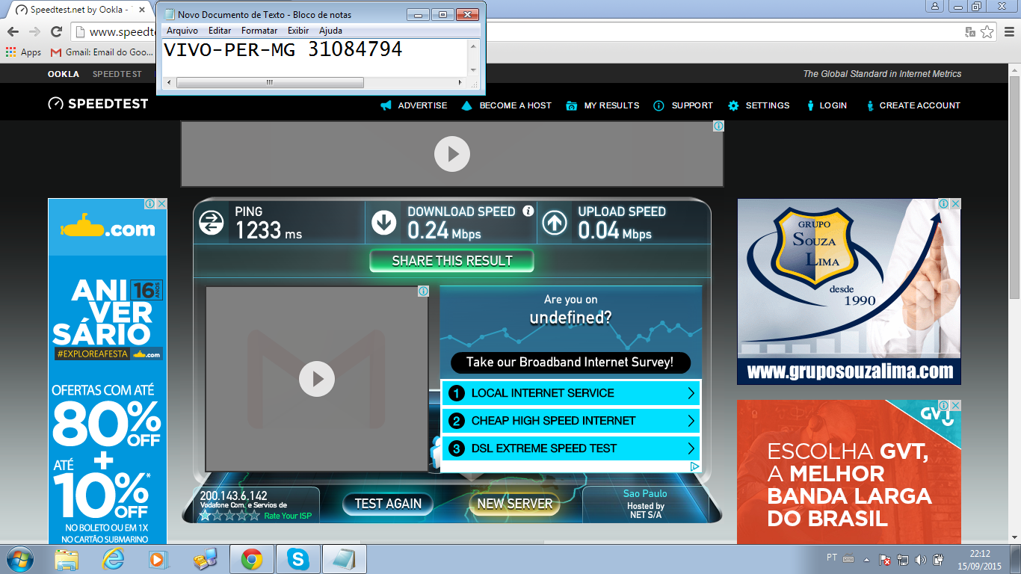

# dvb tx show

Satellite (DVB) TX Configuration
--------------------------------
Auto start : Enabled
IDU Output Power : -30 dBm
IDU Max Output Power: 0.0 dBm
ODU Output Power : 33.7 dBm
EIRP : 47.0 dBW
Default CW Frequency: 0.000000 GHz
ATM mode : VC-Mux
Header Compression : None

Satellite (DVB) Transmitter Status
--------------------------------
State : On (TDMA)
IDU Output Power : -26.5 dBm
ODU Output Power : 33.5 dBm
EIRP : 46.8 dBW
Es/No : 14.0 dB
Header Compression : Disabled
Timing correction : -114 us (262473 us)
Frequency correction: -310 Hz
# dvb rx show

Satellite (DVB) RX Configuration
--------------------------------
Auto start : Enabled
Max MODCOD : 23 16APSK-9/10 (SNR threshold: 23.5 dB)
RX watchdog : 15 minute

Idx Pri SymbRate[Msps] Freq[GHz] Mode PopId Enable
* 0 0 9.320000 12.055825 DVB-S2 4 Yes

Satellite (DVB) Receiver Status
--------------------------------
Rx State : On
DVB State : Forward link up
Network : 1326, GlobalIP@Telstar-14R
Frequency : 12.055923 GHz
Symbol Rate : 9.319996 Msps
S2 ModCod
- receiving : 16 8PSK-8/9
- current max : 23 16APSK-9/10
Pilot : On
Frame length : Short
DVB S2 Mode : ACM
Roll off : 0.25
SNR : 13.9 dB
Input Power : -23 dBm
#

IP DVB 10.53.0.144/32

Ping desde o MGMT- Server ao IP de trafego e para o DVB.

Ping desde dentro da VSAT 8.8.8.8

# ping 8.8.8.8
64 bytes from 8.8.8.8: time=1320 ms
64 bytes from 8.8.8.8: time=890 ms
64 bytes from 8.8.8.8: time=740 ms
64 bytes from 8.8.8.8: time=740 ms
64 bytes from 8.8.8.8: time=730 ms

